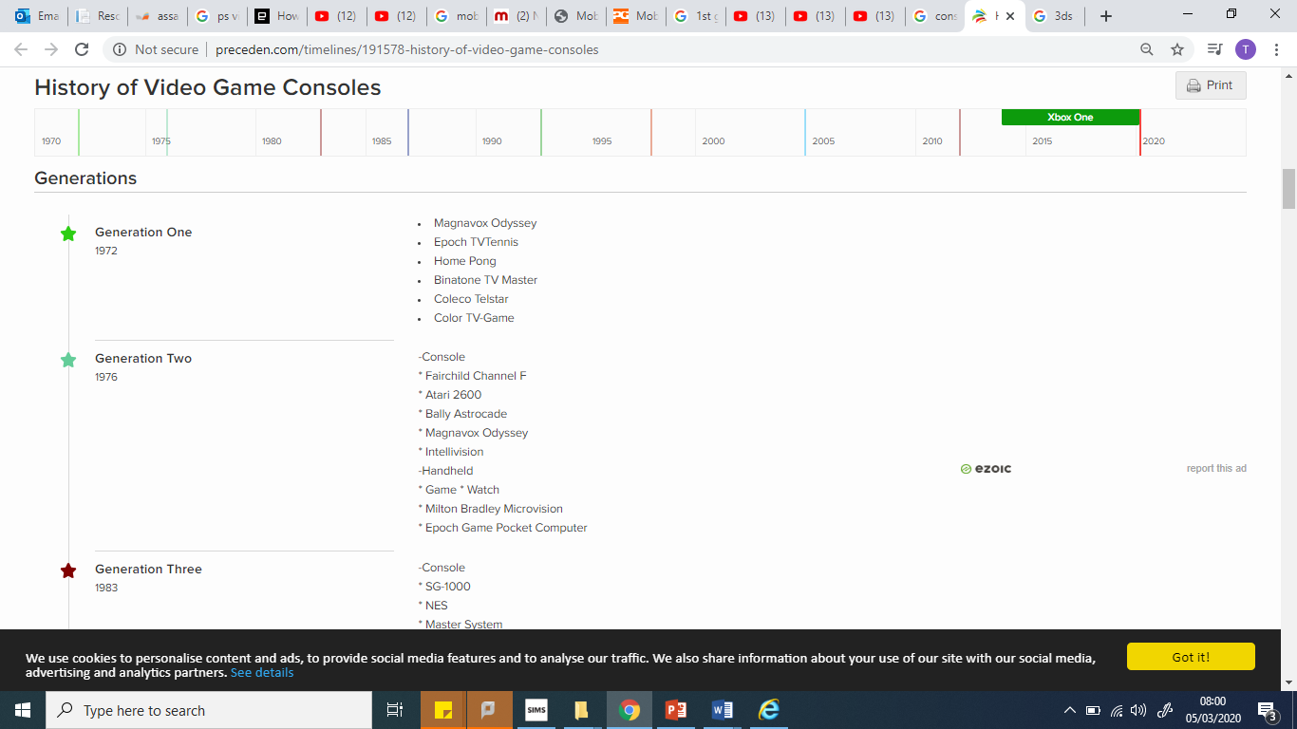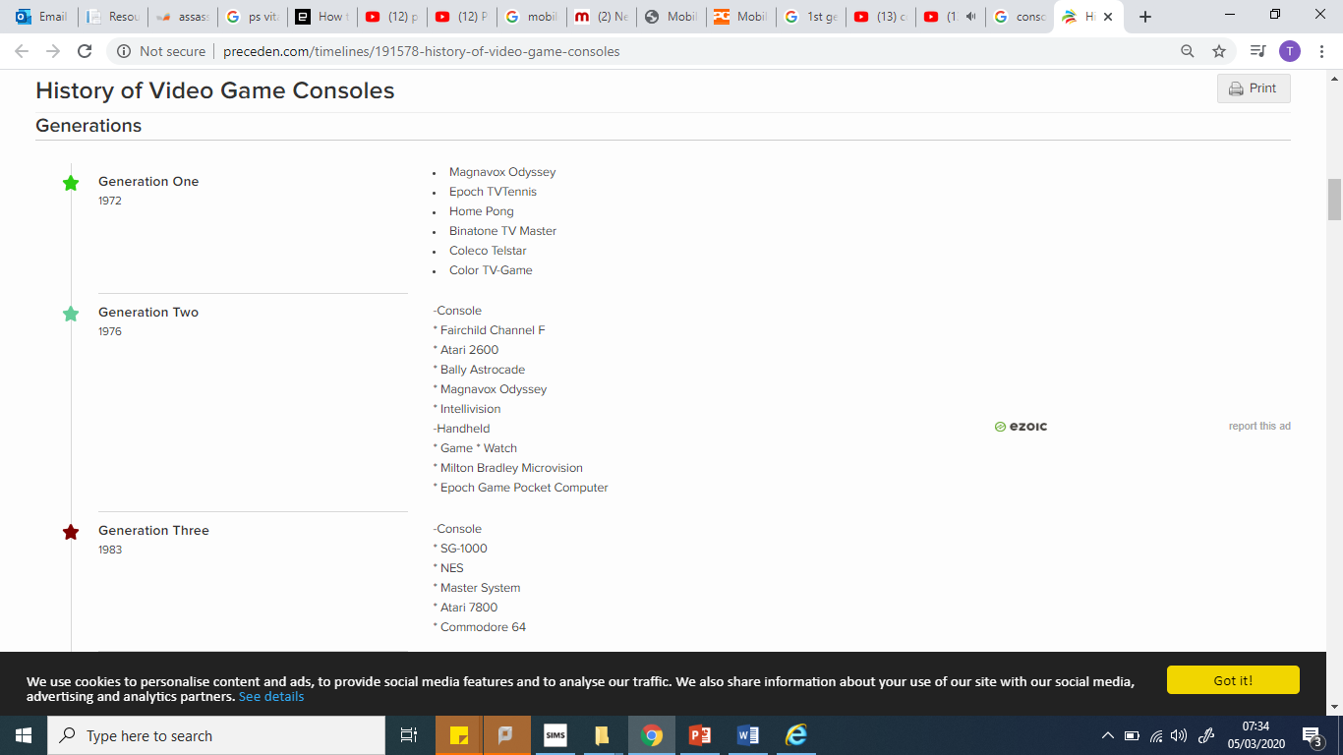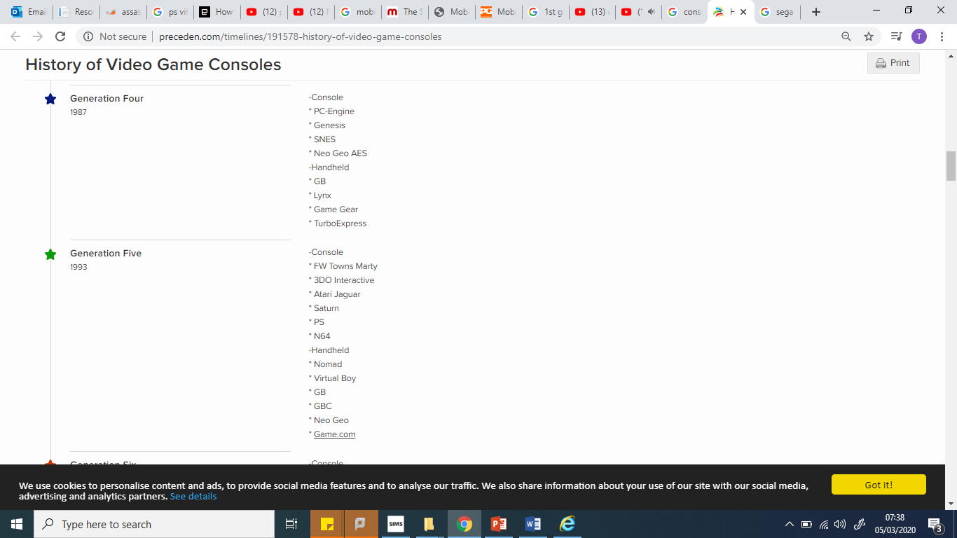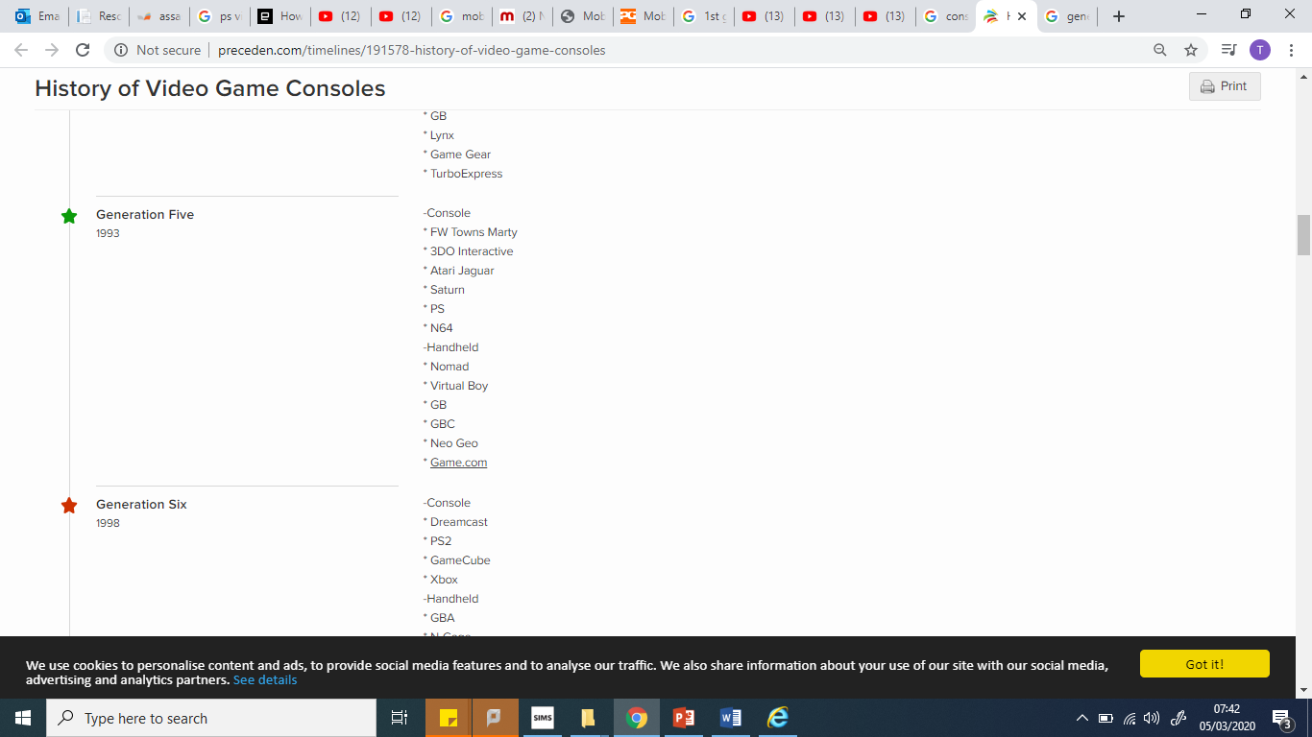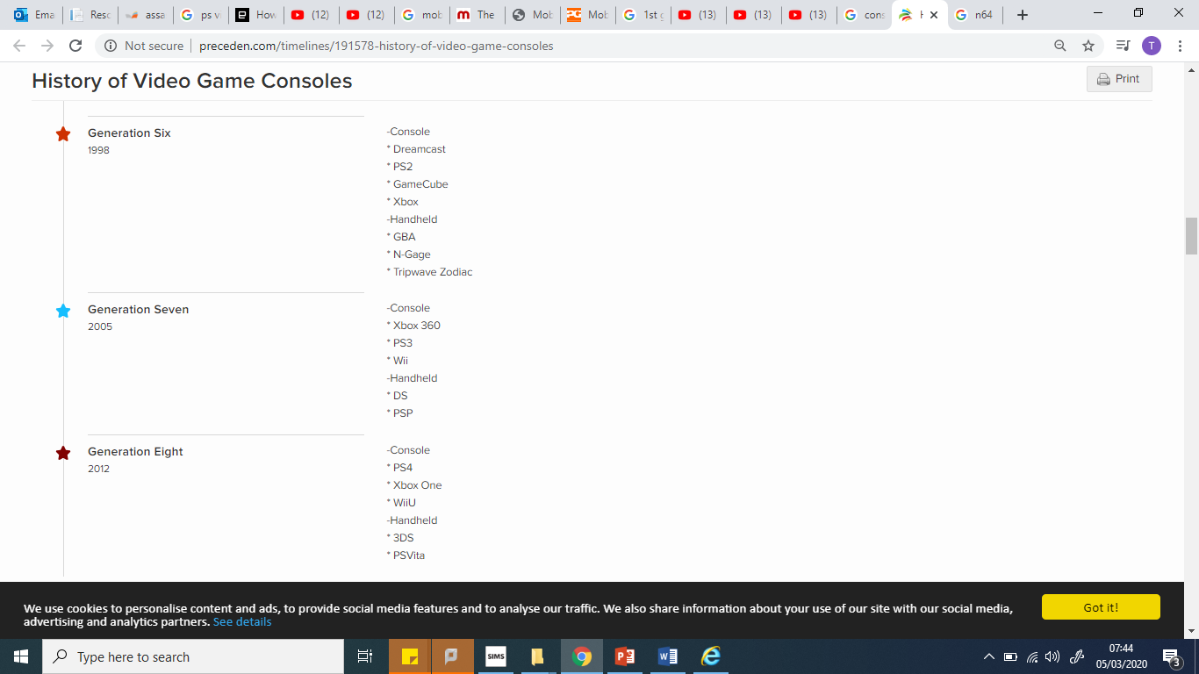

Generation 7 notes

How did the XBOX 360 monopolise the industry to begin with?

What new technological developments were there during gen7?

How was web 2.0 featured within gen 7?

Generation 8 notes

What is the current rivalry? Why is rivalry healthy for the industry?

Where is the video games market going? Is it healthy

What are the most revolutionary technological advancements to date? What reputation do video games have? Why can the video game industry now be considered a huge cultural product?

Generation 6 notes

What happened to SEGA? Why did they stop developing consoles and focus solely on games development? What is the most sold console? How did it use convergence to its advantage?

What did XBOX have that was unique?

Generation 5 notes

Why was the 5th generation a “shit show”?

Who were beginning to become the first gaming conglomerates?

What was revolutionary with the gaming graphics?

What did SONY do that was new?

Generation 4

How did the Sega Genesis respond to consumer demands?

What was the first real console rivalry?

Which console started building “franchises” first?

Generation 3 notes

Who got the gaming industry out of the slump?

What concepts were used to market the NES?

Generation 2 notes

What was the first “read” home console? How much was the gaming industry worth? Why was there a video game crash? Why?

Generation 1 notes

Why were the first gaming consoles created?