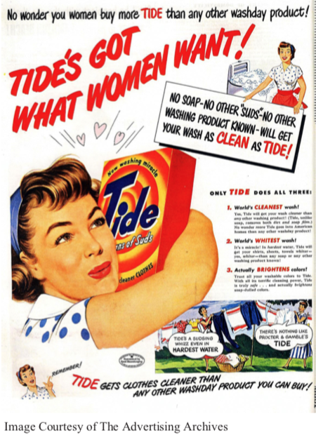

How has the historic social and cultural contexts been portrayed on the *Tide* advert?

How has the *Tide* advert attached meaning with the use of media language?

How has the *Tide* advert targeted female buyers?

How has the historic economic context been portrayed on the *Tide* advert?

How have the intertextual references of “Rosie the Riveter” and “Women’s Land Army” been used?

Key Words:

1.

2.

3.

4.

5.

6.

7.

8.