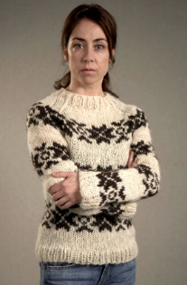

Key Scene 1. What happens? What impact does it have on the audience? What use did it serve for the narrative?

Key Scene 4 What happens? What impact does it have on the audience? What use did it serve for the narrative?

Final Key Scene What happens? What impact does it have on the audience? What use did it serve for the narrative?

Key Scene 3 What happens? What impact does it have on the audience? What use did it serve for the narrative?

Key Scene 2 What happens? What impact does it have on the audience? What use did it serve for the narrative?

What was the overall use of the narrative strand? What effect and impact did it have on the viewer and the story? What was the overall journey?

Key Scene 1. What happens? What impact does it have on the audience? What use did it serve for the narrative?

Key Scene 4 What happens? What impact does it have on the audience? What use did it serve for the narrative?

Final Key Scene What happens? What impact does it have on the audience? What use did it serve for the narrative?

Key Scene 3 What happens? What impact does it have on the audience? What use did it serve for the narrative?

Key Scene 2 What happens? What impact does it have on the audience? What use did it serve for the narrative?

What was the overall use of the narrative strand? What effect and impact did it have on the viewer and the story? What was the overall journey?

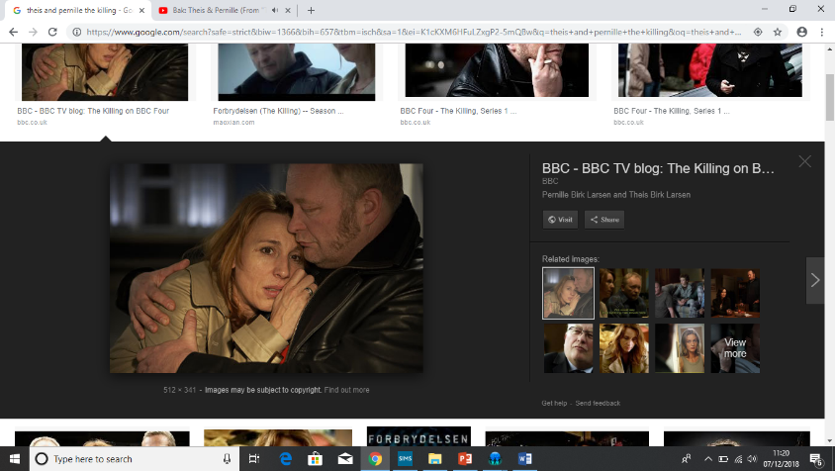

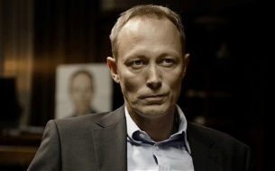

Key Scene 1. What happens? What impact does it have on the audience? What use did it serve for the narrative?

Key Scene 4 What happens? What impact does it have on the audience? What use did it serve for the narrative?

Final Key Scene What happens? What impact does it have on the audience? What use did it serve for the narrative?

Key Scene 3 What happens? What impact does it have on the audience? What use did it serve for the narrative?

Key Scene 2 What happens? What impact does it have on the audience? What use did it serve for the narrative?

What was the overall use of the narrative strand? What effect and impact did it have on the viewer and the story? What was the overall journey?

What type of storyline does The Killing deal with?

Which character is at the centre of The Killing and what does the character do each episode? (Think whodunit)

What do Hollywood Crime Dramas tend to focus on? (Think CSI etc.)

How does this compare to The Killing? What else is focussed on?

What does the narrative arc of episode 1 revolve around? (beginning middle end)

What are the three main narrative strands and what are their uses within the first episode?