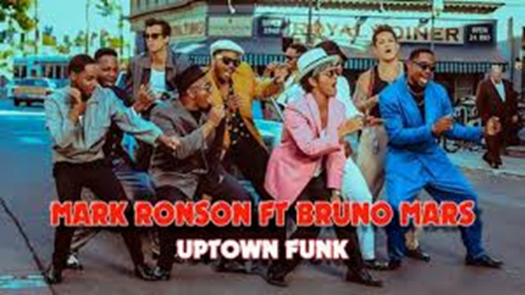

**Genre**

Bruno Mars – Uptown Funk falls under the “Performance” genre. List some examples of the genre’s conventions being conformed to specifically from the video itself.



**Media Language & Representation Analysis**

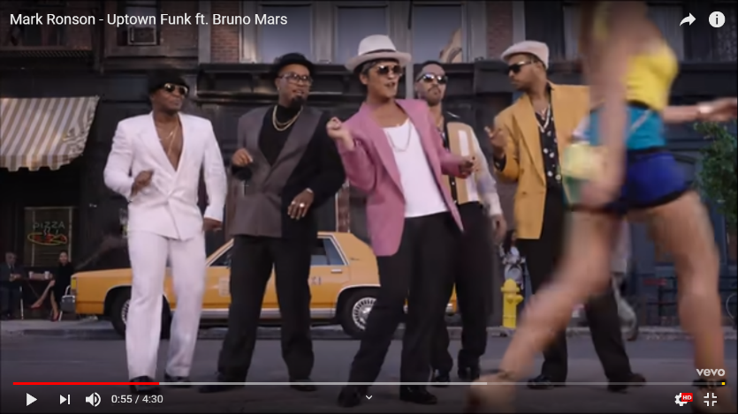

*Long shot of Bruno and backup dancers wearing colourful suits and sunglasses. Slim woman walks past wearing short shorts and bright yellow top. The framing puts Bruno in the centre and only the lower half of the woman is shown.*

*What are the connotations of the denotative comments above?*

*How has gender been represented in this shot?*

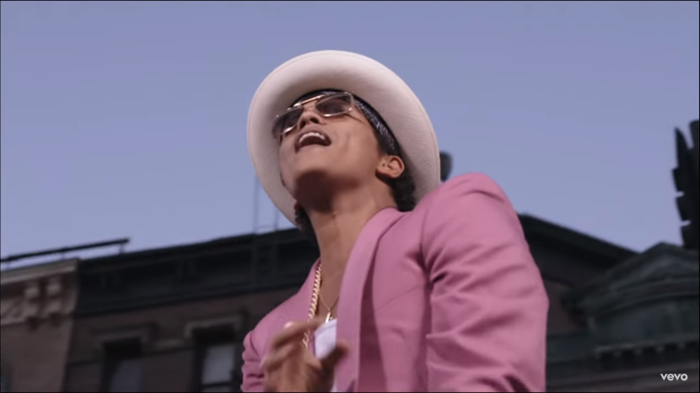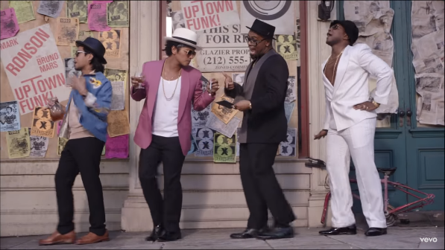

*Low-angle medium shot of Bruno Mars looking towards the bright blue sky whilst singing “girl sent you halleluiah”. Bruno is also wearing a holy cross silver necklace. The lighting is natural yet high-key.*

*What are the connotations of the denotative comments above?*

*How has gender been represented in this shot?*

*Long shot of Bruno Mars and the backup dancers wearing smart casual and colourful clothing. Bruno Mars is holding a glass of cognac and signing a check at the same time.*

*What are the connotations of the denotative comments above?*

*How has gender been represented in this shot?*

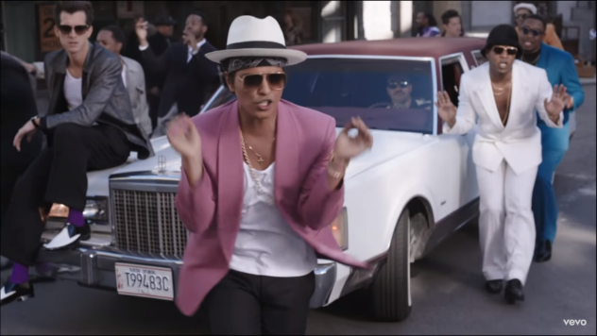

*High-angle long shot of Bruno Mars dancing in front of a white and pink limousine, which is surrounded by back up dancers. The dancers are all dressed up smart with colourful suits. Bruno himself is wearing white and pink.*

*What are the connotations of the denotative comments above?*

*How has gender been represented in this shot?*

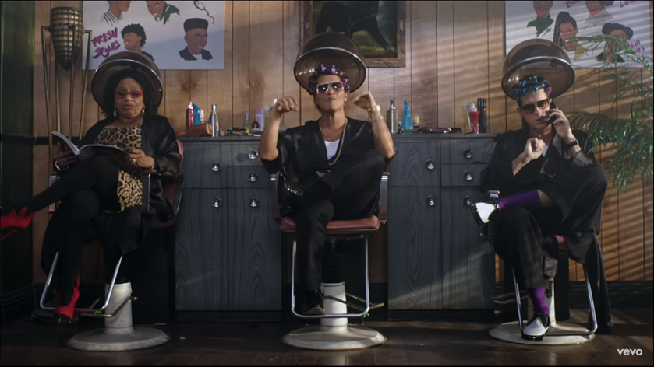

*Bruno Mars is sat with rollers in his hair at a conventional beauty salon. There is an older black woman reading a magazine next to him. All characters are wearing sunglasses inside. The lighting is natural and seems to be filtering in from the window, casting the shadow of the blinds on the back wall.*

*What are the connotations of the denotative comments above?*

*How has gender been represented in this shot?*