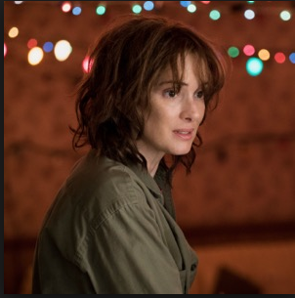

Key Scene 1. What happens? What impact does it have on the audience? What use did it serve for the narrative?

Key Scene 4 What happens? What impact does it have on the audience? What use did it serve for the narrative?

Final Key Scene What happens? What impact does it have on the audience? What use did it serve for the narrative?

Key Scene 3 What happens? What impact does it have on the audience? What use did it serve for the narrative?

Key Scene 2 What happens? What impact does it have on the audience? What use did it serve for the narrative?

What was the overall use of the narrative strand? What effect and impact did it have on the viewer and the story? What was the overall journey?

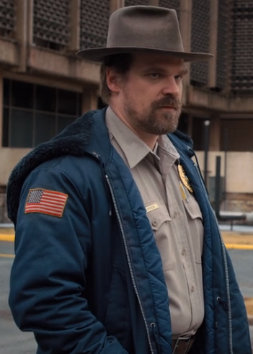

Key Scene 1. What happens? What impact does it have on the audience? What use did it serve for the narrative?

Key Scene 4 What happens? What impact does it have on the audience? What use did it serve for the narrative?

Final Key Scene What happens? What impact does it have on the audience? What use did it serve for the narrative?

Key Scene 3 What happens? What impact does it have on the audience? What use did it serve for the narrative?

Key Scene 2 What happens? What impact does it have on the audience? What use did it serve for the narrative?

What was the overall use of the narrative strand? What effect and impact did it have on the viewer and the story? What was the overall journey?

Key Scene 1. What happens? What impact does it have on the audience? What use did it serve for the narrative?

Key Scene 4 What happens? What impact does it have on the audience? What use did it serve for the narrative?

Final Key Scene What happens? What impact does it have on the audience? What use did it serve for the narrative?

Key Scene 3 What happens? What impact does it have on the audience? What use did it serve for the narrative?

Key Scene 2 What happens? What impact does it have on the audience? What use did it serve for the narrative?

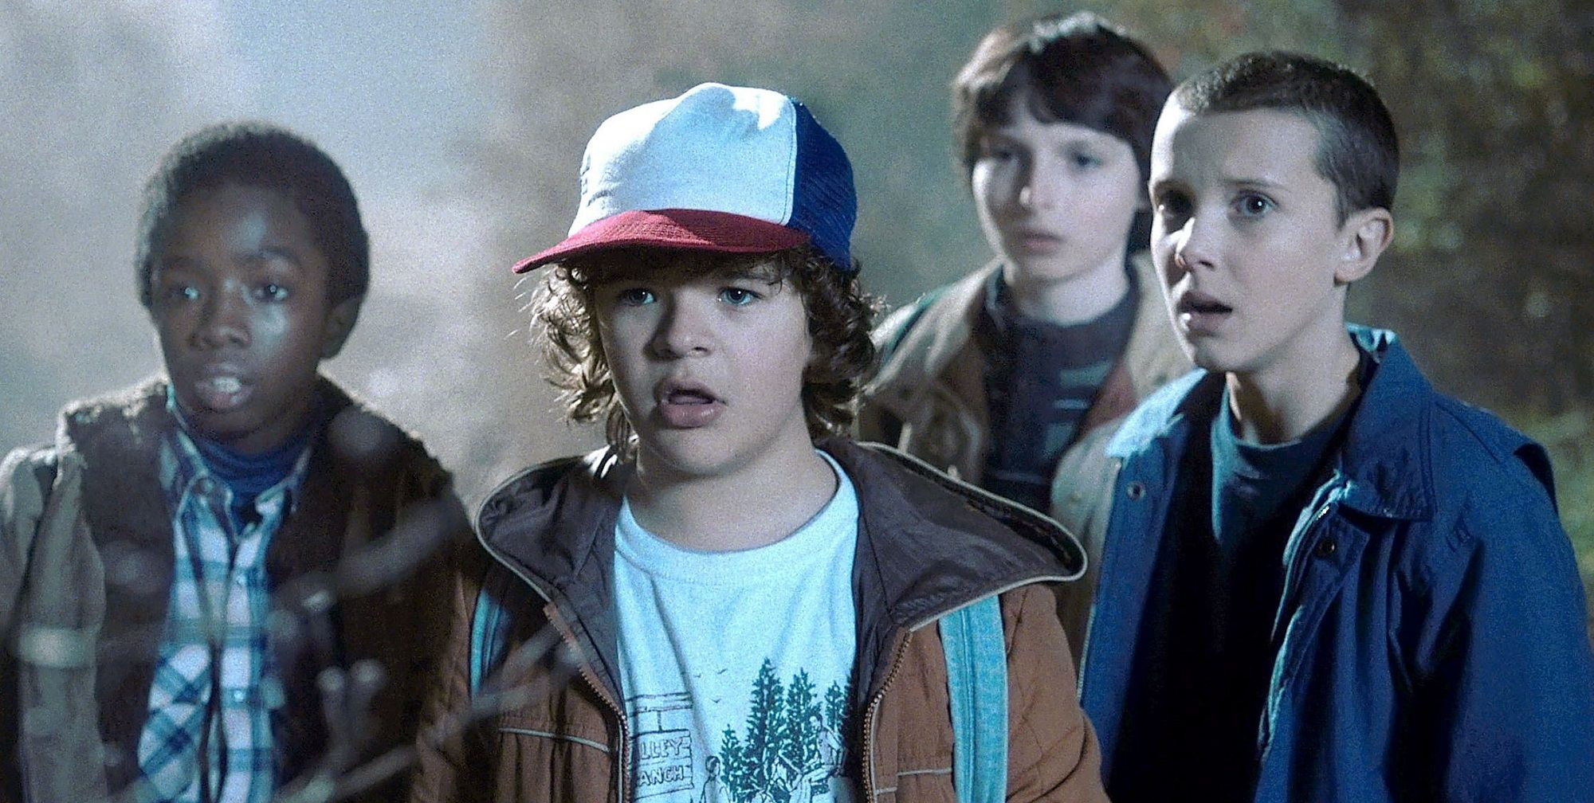

What was the overall use of the narrative strand? What effect and impact did it have on the viewer and the story? What was the overall journey?

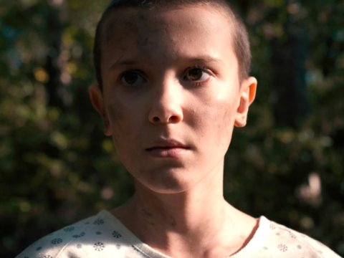

What was the overall use of the narrative strand? What effect and impact did it have on the viewer and the story? What was the overall journey?

Key Scene 1. What happens? What impact does it have on the audience? What use did it serve for the narrative?

Key Scene 2 What happens? What impact does it have on the audience? What use did it serve for the narrative?

Key Scene 3 What happens? What impact does it have on the audience? What use did it serve for the narrative?

Key Scene 4 What happens? What impact does it have on the audience? What use did it serve for the narrative?

Final Key Scene What happens? What impact does it have on the audience? What use did it serve for the narrative?

What type of storyline does Stranger Things deal with?

Which character is at the centre of Stranger Things and what does the character do each episode?

What do Hollywood Dramas tend to focus on?

How does this compare to Stranger Things? What else is focussed on?

What does the narrative arc of episode 1 revolve around? (beginning middle end)

What are the three main narrative strands and what are their uses within the first episode?