

The coverline “The essential wellness gadgets” links to the social context because…

The Strapline informs the audience that it is a special issues dealing with “Mind, Body and Masculinity”. This infers…

Dwayne Johnson features in the centre of the magazine and dominates the front page. The reason behind this may be to…

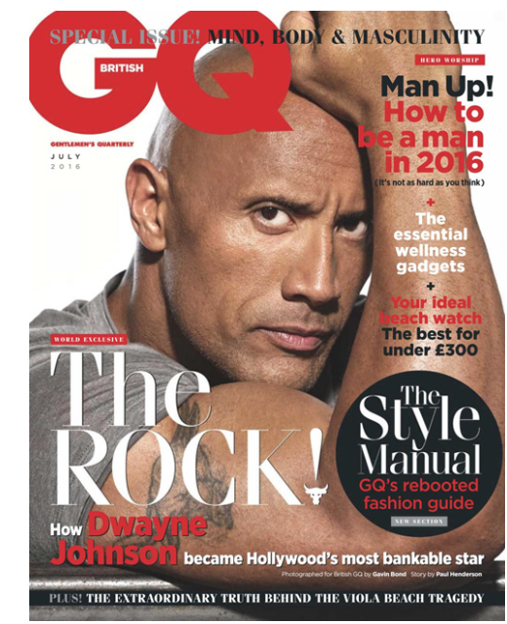

The coverline on the right third of the cover states “Your ideal beach watch. The best for under £300” suggests that the audience…

The Main Coverline reads “World Exclusive – The Rock! How Dwayne Johnson became Hollywood’s most bankable actor”.

“World Exclusive” has connotations of…

“Bankable” infers…

Within the main coverline, “THE ROCK” takes up a large section of the bottom third of the magazine. This was done to…

The exclamation mark has a bull head included, which has connotations of…

“Dwayne Johnson” is written in red, which has associated meanings of…

The coverline futher down reads “The Style Guide”. This is influenced by our cultural context because…

“Style Guide” has connotations of…

Johnson’s has a tanned face and is clean-shaven and looking well kept. This relates to current social context because…

Johnson’s facial expression is quite serious, and he is looking directly at the audience. This suggests..

There is an extreme close-up of Dwayne Johnson flexing his biceps whilst wearing a tight fitted T-shirt. This has connotations of...

The colour palette of red, white and red have connotations of…

The Strapline “Plus! The Extraordinary Truth Behind The Viola Beach Tragedy” suggests that GQ…

The word “Extraordinary” is an example of…